**The Hunger Games**

**An Analysis on Canadian Food Affordability**

**Introduction**

It’s 2017, Saturday night in mid-July, and you go out with your friends to celebrate your best friend’s birthday. It’s been a great night and before going home you decide to grab something to eat. Kim Anh on 17the Ave has great Vietnamese subs and for only $8.50 you get one of the best Viet subs you’ve had in years. Fast forward to 2024, your parents are visiting and you walk past Kim Anh. You haven’t been there since that night and you decide to get dinner for everyone, but wait, the same Tofu sub now goes for $15.

This is a story that all Canadians can relate to. Even though price increases might be more noticeable when dining out, our grocery bills are also increasing bit by bit. The cost of living is currently one of the top concerns for Canadians (Kishchuk, 2023), especially since food inflation reached a 40-year high of 10.4% at the beginning of 2023 (Shahbandeh, 2024). It is reported that as of 2022 Canadians spend an average of 17% of their disposable income on food (Charlebois et al., 2023) and this percentage is much greater for Canadians living with a tight budget.

**Key terms**

**Food security** can be described as the condition where the whole population has reliable access to enough nutritious food (Peng & Berry, 2019). It refers to a situation where access to food is constrained by financial resources. It is worth pointing out that it does not only involve a general lack of access to food, but also limited access to nutritious food.

In 2018, Canada’s Poverty Reduction Strategy introduced food security as an indicator, and soon after during the same year, the Canadian Income Survey (CIS) decided to monitor food insecurity in Canadian households (Tarasuk et al., 2021). The CIS tries to cover the full spectrum of food insecurity “from worrying about running out of food, to children not eating for a whole day" (Government of Canada, Statistics Canada, 2023).

The CIS evaluates food insecurity based on a series of questions that are available in APPENDIX 2 These questions are then categorized into 3 distinct levels: mild, moderate, and severe food insecurity. Mild food insecurity is those who may have to limit food selection and/or worry about running out of food due to financial constraints. Moderate food insecurity is those who may reduce the quality and/or quantity of food they buy because of cost. Severe food insecurity includes those who miss meals or even go days without food.

A key factor of food security and adequate nutrition is **food affordability**. “[Food Affordability] can be defined as the capacity to pay a market price for food compared to the proportion of a household’s income and other expenses.” (WBCSD, n.d.). The significance of this issue relies on its broad repercussions, which can have a substantial impact on different aspects of physical and mental health (Daly et al., 2018).

**Agenda and Guiding Questions**

In this report, we will explore the current and complex issue of food affordability and its relation to food security, individual food prices, and annual income in Canada using the latest available data from Stas Can. We will use the Canada Food Guide as a basis to assess a healthy diet and analyze the potential impact to Canadians in the lower income tax bracket. We will investigate population trends and how the relative growth is related to food price index increase. We will evaluate food affordability trends by comparing after-tax family income and spending on food. By analyzing provincial data, we will gain insights into food insecurity across Canada’s major provinces, ultimately presenting a comprehensive understanding of food security and affordability in the country. Our Agenda is led by the guiding questions proposed below:

**Healthy Eating**

- What does the latest Canada Food Guide consider to be a healthy diet?

- How much does a healthy diet cost for a vegetarian and non-vegetarian Canadian based on food price data available on Stats Canada?

**Growing Population, Increasing Prices**

- How are food prices increasing per province relative to the provincial population growth?

- Can we predict trends in food price changes based on population growth rates?

**Income Ranges**

- How many households fit into income categories defined by Canada’s 2021 income tax brackets?

- Are there specific provinces that have higher/lower household income after tax in Canada?

**Money In, Money Out**

- How much money do Canadian households make relative to the amount they spend on food?

- Are there any specific provinces or income brackets that have to spend disproportionately more on food?

**The Core Problem: Food insecurity**

- How has food insecurity changed in Canada from 2018-2021?

- What are the most and least food insecure provinces in Canada and why?

- What have been the most significant years for food insecurity between 2018-2021?

- What levels of food insecurity can we find among the portion of Canadians that fall into the lowest household income bracket?

**Literature Review**

Although this is a well-researched topic, as our first dive into data science, we were interested in coming up with our own conclusions and to compare our findings with other published research.

Having said this, there is only one organization (PROOF from the University of Toronto) that focuses on researching food insecurity in Canada (for what it’s worth, we were not aware of them until a few days before the project submission deadline).

1. Tarasuk, V., Li, T., & Fafard St-Germain, A. A. (2022). *Household food insecurity in Canada, 2021*. Toronto: Research to Identify Policy Options to Reduce Food Insecurity (PROOF). Retrieved from [https://proof.utoronto.ca](https://proof.utoronto.ca/)

While their research is very close to ours, they focus on food security and the impact on a series of internal and external factors that affect this condition.

1. Charlebois, S., Ducharme, M., Morrison, M., Vézeau, J., & Taylor, S. (2023). The Local Food Paradox: A second study of local food affordability in Canada. *Sustainability*, *15*(6), 5199. <https://doi.org/10.3390/su15065199>

This study focuses on food affordability in Quebec, and specifically trying to answer the question of whether eating locally in Quebec costs more.

1. *A study of food security programs at Metro Vancouver Housing Corporation*. (2012, August 24). Canada Commons. <https://coilink.org/20.500.12592/s25gfm>

Metro Vancouver Housing Corporation (MVHC) and BC Non-Profit Housing research food security programs at specific sites in Vancouver. The research objectives were determining the impact of food programs on tenants' lives, including food security, health and wellbeing; identifying barriers to food program use; and identify ways of improving food programs and policy directions based on the research findings.

1. Taylor, S., Charlebois, S., & Music, J. (2023). Affordability of Canada's Food Guide: Current challenges amid COVID-19, War in Ukraine, and other world events. *Frontiers in nutrition*, *10*, 1085855. <https://doi-org.ezproxy.lib.ucalgary.ca/10.3389/fnut.2023.1085855>

Published in 2023 and focusing on major world events such as the war in Ukraine and COVID-19, this study analyzes the affordability of the Canada Food Guide in relation to the 2007 edition, concluding that the 2019 edition is easier to follow for kids and teens, but more expensive for adults.

1. Daly, A., Pollard, C. M., Kerr, D. A., Binns, C. W., Caraher, M., & Phillips, M. (2018). Using Cross-Sectional Data to Identify and Quantify the Relative Importance of Factors Associated with and Leading to Food Insecurity. *International Journal of Environmental Research and Public Health*, *15*(12), 2620. <https://doi.org/10.3390/ijerph15122620>

A study into the factors that cause food insecurity and their effects in Australia. The research concludes that “perceived income, independent of actual income was a strong mediator on the path to FI as were obesity, smoking and other indicators of health status.” This study demonstrates the intricate nature of the problem and how complicated it might be to solve it.

1. Government of Canada, Statistics Canada. (2023, November 14). *Food insecurity among Canadian families*. <https://www150.statcan.gc.ca/n1/pub/75-006-x/2023001/article/00013-eng.htm>

Stats Canada has several reports and infographics on food insecurity that are quite relevant. While all our data was sourced from Stats Canada, we focused on a few variables and provided insight from different perspectives. Stats Canada’s reports usually account for a series of factors and do not always touch on the specific same issues that we do.

**Dataset**

Multiple data sets from Stats Canada were used for the completion of this project, including the **Canadian Income Survey** (CIS) from 2018-2021, **“Detailed food spending, Canada, regions, and provinces”** dataset, **“Monthly average retail prices for selected products: Food” dataset,** and “**Population estimates quarterly”.** All references are included on the “Dataset Reference” list.

**1. Canada Income Survey (CIS):**

The CIS is a cross-sectional survey that follows a stratified, multi-stage probability sampling design. This involves dividing provinces into geographical strata, randomly selecting clusters from within these strata, and then selecting dwellings from the clusters. The 2021 CIS data is available as a .csv file in a 207 column, 89,939 row well formatted table, and all other CIS follow a similar format. All variables in the data (qualitative and quantitative) are represented as numerical values that can be standardized or translated. Our columns of interest from the CIS were **Year [YEAR]**, **Province [PROV],** **Economic Family Income After Tax [EFATINC]** (provided by Canada Revenue Agency), and **Household Food Security Status [FSCHHLDM]**.

**2. “Monthly average retail prices for selected products: Food” dataset:**

This dataset is based off information obtained in the Statistics Canada Consumer Price Index. This data comes as a .csv file in a well formatted table that includes 15 columns and 110,020 rows. Our columns of interest include **Reference Date [REF\_DATE]**, **Geographical Area [GEO]**, **Products [Products]**, and **Value [VALUE]**in Canadian dollars.

**3. “Detailed food spending, Canada, regions, and provinces” dataset:**

This dataset is based off information obtained in Statistics Canada Survey of Household Spending. This survey is completed every two years and includes data from 2010 – 2021. The data comes as a .csv file in a well formatted table with 16 columns and 33,294 rows. The columns we will look at include **Year [YEAR], Geographical Area [GEO], Food Expenditures Summary [Food expenditures, summary-level categories]**, and **Value [VALUE]** in Canadian dollars.

4. “**Population estimates quarterly” dataset:**

This dataset contains the quarterly (every3 months) population increase/decrease for the selected period. The data shows an estimation of the absolute number of people residing in each province during the given period. The downloaded data set is a clean well formatted .csv file with one column per year and one row for each province of interest. This was a very straight forward dataset that did not require any cleaning or wrangling. Both variables, **YEAR,** and **GEOGRAPHY,** were used for this report.

**Sources and Licensing:**

All our datasets are from Statistics Canada, and hence fall under their licensing and attribution guidelines. Statistics Canada’s data is open source, which allows any individual to replicate and distribute their data royalty free. Conditions that must be followed when using the data include not distorting information provided, not implying that Statistics Canada has endorsed your work, and not using data to attempt identifying a specific person, organization, or group. For attributions, all data included from Statistics Canada must and will have its source referenced.

**Data Wrangling Procedures:**

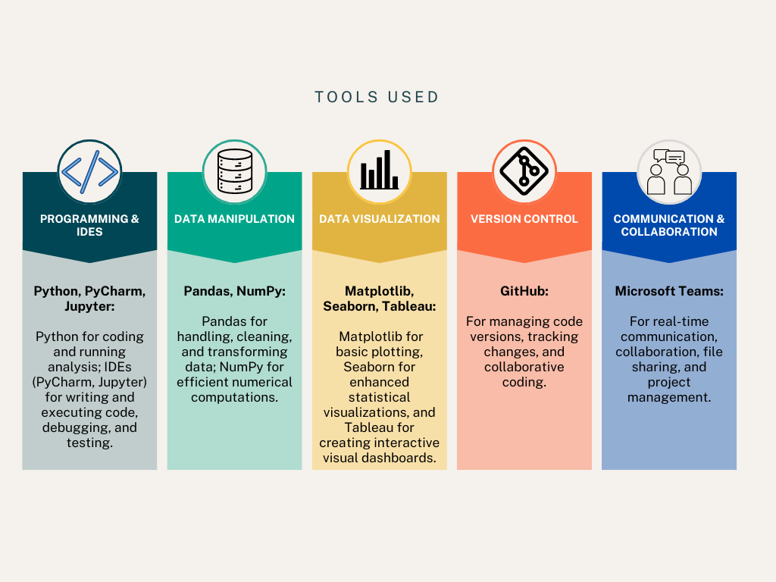

**1. Data Loading and Structuring**

- Loaded five datasets (2017-2021) from the Canadian Income Survey using pandas.

- Created a list of these files to simplify the loading and standardize column order across all datasets based on the 2017 dataset.

**2. Data Cleaning for CIS**

- Merging: The datasets were stacked into a single DataFrame for combined analysis using **pd.concat()**.

- Province Mapping: Replaced numerical province codes with readable province names for better interpretability.

- Handling Missing values: Removed rows with missing values in key columns (e.g., PROV).

- Irrelevant Data: Dropped the MBMREGP column and removed duplicate records to maintain data integrity.

**3. Data Integration**

- The cleaned CIS data was saved as FINAL\_CIS.csv.

- The CIS data was merged with another cleaned dataset, Food Spending (Cleaned\_Food\_Spending.csv), based on common columns (YEAR and PROV), enabling analysis of how income and spending patterns vary across regions and time.

**4. Food Prices Data Wrangling**

- Loaded the Food Prices dataset and extracted relevant product details and units (e.g., product name and quantity).

- Product Classification: Created a custom function to categorize food products (e.g., meat, dairy, vegetables) based on keywords.

- Unit Standardization: Converted the product prices to a standard unit (KG or L) for consistency.

- Filtered data to include only the year 2023, focusing on recent trends.

- Saved the cleaned and categorized food price data as health\_diet\_price.csv.

**5. Food Spending Data Wrangling**

- Cleaned the Food Spending dataset by removing unnecessary columns and filtering the data to focus on specific food expenditure types (Food purchased from stores, Restaurant meals, and Food expenditures).

- Dropped aggregated region-level data like "Canada", "Atlantic Region", and "Prairie Region" to focus on provincial-level analysis.

- Set YEAR, PROV, and Way\_to\_Spend as multi-index to facilitate hierarchical analysis and saved this as Cleaned\_Food\_Spending.csv.

**6. Final Merge**

- The final merged dataset, combining CIS and Food Spending data, was saved as CIS\_Food\_Spending\_merged\_data.csv. This dataset provides a comprehensive view of how income levels and food spending habits vary across provinces and years, offering valuable insights for further analysis and visualizations.

This encapsulates the key steps taken by wrangling to create a unified, clean, and structured dataset for analysis. We completed this to ensure quality and consistency for deeper insights into Canadian income and food spending trends. The repository of all coding used for data wrangling in this project is included in APPENDIX 1.

**TABLEAU**

Since no specific requirements were given for which software to use for data visualization in our project guidelines, we chose to use Tableau. We wanted to create the most informative graphical representations of our data as possible and felt that Tableau was the best software to create these visualizations and to work with our data. To start, we downloaded the full version of Tableau with our uCalgary student access. To learn more about Tableau and its functionality, each team member completed independent learning through YouTube and online guides provided by Tableau.

To start our analysis, we loaded all of our datasets in Tableau. From there, Tableau gives you the functionality to select for specific variables in your data set and create them into preformatted visualizations through defining select variables as rows and/or columns. There are many intricate functionalities in Tableau intrinsically included in the software, which help streamline the process of making plots. We learned how to create simple calculated fields to allow us to include virtual columns to our data set. For example, when creating a histogram, the data set might not explicitly contain a column with the total number of entries per variable and a calculated field can do the job. When working with percentages, a calculated field can answer what percentage of the total population falls into X variable filter. We learned to work with discrete and continuous variables. We changed categorical variables (such as the year or food insecurity level) to ‘dimensions’ so that these numbers were not added or subtracted as the software sometimes does by default. We learned to filter, sum and group/categorize data within the software.

One of the most reveling parts of working with Tableau was the potential to be creative and try out different variations of visualizations with ease. Once we had the visualization that we initially intended to create, we tried the other plotting options, and thus we could test bar charts, stacked bar charts, pie chart, trend plots, etc. in a very user friendly format. Thus, we tested a variety of visualizations and selected the most appropriate for our guiding questions and the story we had in mind for the report.

**Analysis**

1. **Healthy Eating**

**Objective:** To **compute** the cost of a nutritious diet for anyone living in Canada based on the Canada Food Guide.

**Guiding questions:** What does the latest Canada Food Guide consider to be a healthy diet? How much does a healthy diet cost for a vegetarian and non-vegetarian Canadian based on food price data available on Stats Canada?

**Insights:**

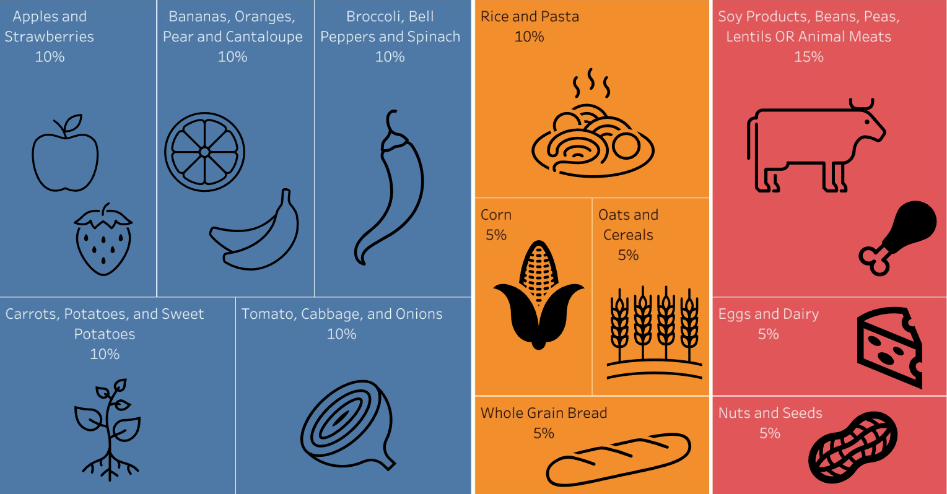

Figure 1: Diagram of healthy diet recommended by the 2019 Canada Food Guide.

Even though the Canda Food Guide recommends that we all consume 50% of fruits and vegetables, 25% of whole grains and 25% of animal product/protein and nuts and seeds (figure 1), very few of us follow these recommendations. Most of the time we like to consider the nutritious value of our meals, but based on this recommendation, I don’t think we get the portions right most of the time.

In the last few decades our diets have changed to include unhealthy amounts of process and ultra-processed foods, sodium, sugar, fats and high-caloric foods (Gorski & Roberto, 2015). But there has also been a trend in rich countries of healthy eating, where about 70% of consumers want to eat healthier, with 50% saying this is a top priority. COVID played a major role in changing eating patterns of consumers who now report eating more fresh produce, healthier foods, and cooking more at home (Grimmelt et al., 2022).

But let’s face it, in this fast-paced world, and especially for us students coursing DATA 601, there is not enough time to go grocery shopping and cooking. According to a study from the European Journal of Clinical Nutrition, this is the major reason why most Europeans don’t eat healthily, followed by having to give up some of our favorite foods (Lappalainen et al., 1997). After all who would give up ice cream, or bacon? But if this isn’t enough to make you eat healthier, let’s take a look at how much it actually costs.

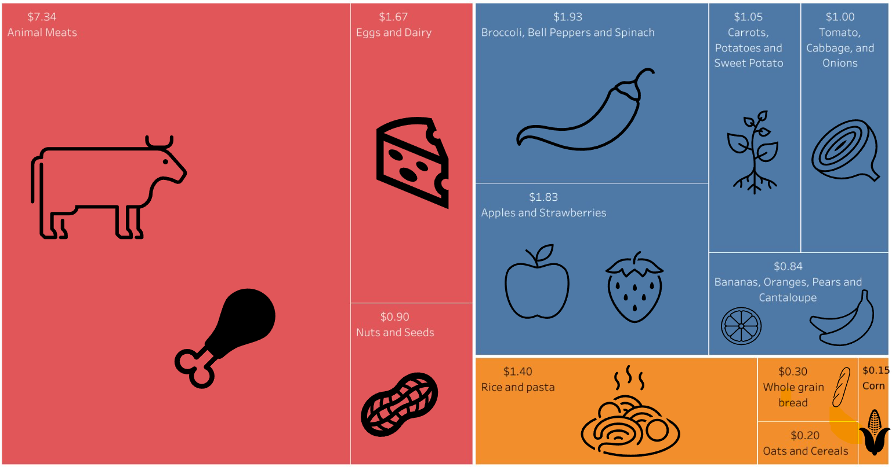

Figure 2: Diagram of the cost of a healthy diet per day as recommended by the Canada Food Guide for a Male adult who eats meat.

It is worth pointing out that the suggestion from the Canada Food Guide can apply to anyone: kids, adults and the elderly. It only involves readjusting your regular portions to match the 50%, 25%, 25%. To give an estimated cost, we must come up with a suggested diet (figure 2). And have specific serving sizes for each food group. These two factors are only provided for Male Adults in the Canada Food Guide. Health Canada suggests each ‘fruits and veggies’ portion to be around 125ml (1/2 cup) of fresh, frozen or canned fruits/veggies or 1 piece of fruit/veggie. Grain foods’ portions would include 1 slice (35g) of bread, or 125 ml (1/2 cup) of cooked rice, pasta, couscous, or 30g of cold cereal/grains. Lastly, for animal protein (or plant-based protein) 75g or 125ml (1/2 cup) cooked mean, or 175ml (3/4 cup) of cooked legumes or tofu, or 60ml (1/4) cup of nuts and seeds, PLUS lots of water (Canada’s Food Guide, n.d.).

Based on our analysis, the total cost of food per day is $18.60, and $6,547.20 for a full year. This is only for the main nutritional components of meals, and doesn’t include spices, condiments, or sauces. Grocery bills commonly go over this cost due to other essentials that are purchased such as toiletries or cleaning supplies. At this point, you might think to yourself: ‘Wow maybe I should go vegetarian’, and maybe you should. As seen on the next figure, you would be saving some money while eating healthy.

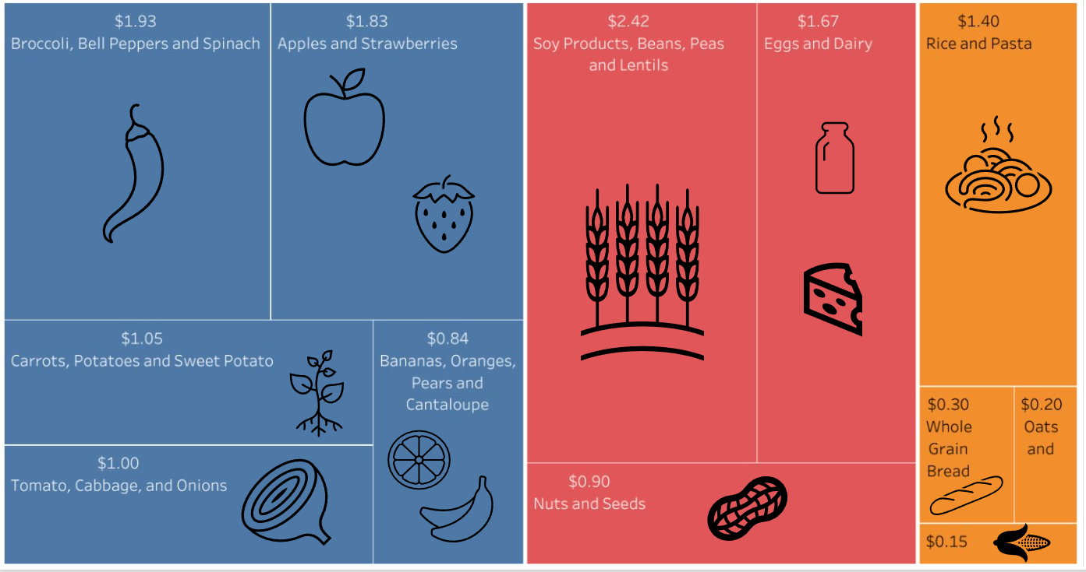

Figure 3: Diagram of the cost of a healthy vegetarian diet per day as recommended by the Canada Food Guide for a Male adult.

By the same metrics used above, a basic vegetarian diet (figure 3) costs you $13.70 per day or $4,822.40 per year. Eating vegetarian could save you money in the long run, but it can be hard for many to transition into a meat free diet when it is a staple in their diet.

**Key findings:**

* A healthy diet comes at a considerable cost for Canadian struggling to make ends meet, especially when you factor in general expenses that come with the cost of living in Canada.
* A basic non-vegetarian diet will cost around $6.5k a year compared to $4.8k for a basic vegetarian diet

**2. Growing Population, Increasing Prices**

**Objective:** To **investigate** the relationship between the major province’s population and the rise in food price from 2017 to 2024*.*

**Guiding questions:** How are food prices increasing per province relative to the provincial population growth? Can we predict trends in food price changes based on population growth rates?

**Insights:**

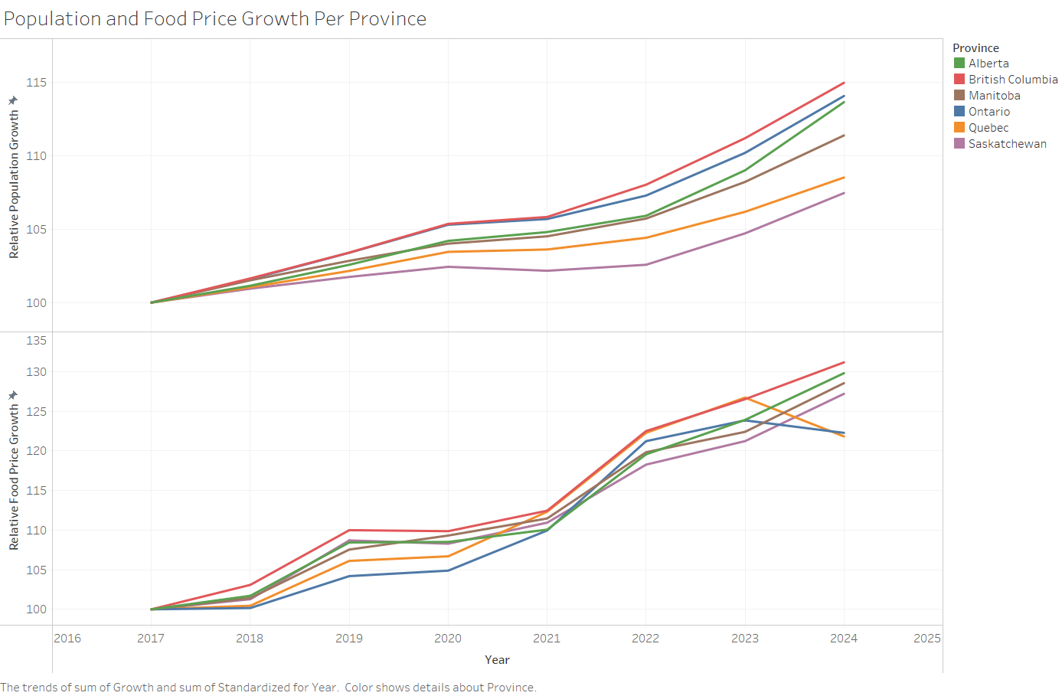

Figure 4: Trends for relative population growth and food price increase from 2017 to 2024 in the major Canadian provinces.

When considering food affordability, an essential element to consider is how many people populate an area and how this may affect food pricing. When there are more people in an area, this increases food demand. Food providers must either increase supply to keep up with this demand, or increase prices based on their limited supply. To help visualize this, we analyzed population growth data and how it relates to food pricing in each of the non-Atlantic provinces Population growth is presented using 2017 as the standard, with each subsequent year reflecting a percentage increase in population relative to 2017(figure 4).

It’s not a secret that the cost of living in B.C. is the highest in Canada (Chase, 2024). Contrary to expectations being the highest cost to live, B.C. is the fastest growing province in Canada. Furthermore, our data shows that not all the stories that you’ve heard about people moving from Toronto and Vancouver to Calgary are false. From April 2023 to April 2024, Alberta's population grew by 4.4%, which was more than any other province (Rodrigues, 2024). This increase can be seen on the plot by a drastic change in slope for the Alberta population trend line from 2023 to 2024.

To analyze average food pricing, we examined data on food prices for specific categories and provinces over time. The food pricing data we collected was initially split into specific foods, so we grouped and converted their prices to represent standardized values. We adjusted each food to be cost per unit (kg or L), and grouped food into categories such as meat, fruits, veggies. We leveraged this standardized data to create a plot of average annual food prices in each analyzed province. We took the same approach as our population plot to display this data, using 2017 food prices as our standard, with each subsequent year reflecting the percentage increase in food prices relative to 2017.

While it’s no surprise that food prices have increased significantly over the past seven years, Ontario and Quebec appear to be exceptions. In the last year, they successfully reduced the average cost of food, something that no other major province was able to do. After extensive research, it is still not clear how and why this is happening (this might have something to do with my inability to read in French). We do know that in 2024 the federal government met with the CEOs of Canada’s largest grocery chains to be questioned about rising prices for groceries (The Fraser Institute, Whalen, & Fuss, 2023). While there has been no indication of any repercussions, we hope the government doesn't take its eye off it.

It is worth explaining how this standardization works, because if you are a Saskatchewanian seeing the food price increase plot, you might think to yourself: “I’m selling my farm and moving to Ontario”, but this is probably not the best idea. In Ontario the cost of food is still higher than that in Saskatchewan. Ontario’s average food price index (AFPI) started at $9.119 in 2017 per KG/L vs $8.709 for Saskatchewan. By 2024, Ontario’s AFPI is now at $11.49 per KG/L but Saskatchewan’s is at $11.07. While Ontario’s AFPI is still higher than Saskatchewan’s the growth rate was less. Ontario’s AFPI grew 22.3% from 2017 to 2024, while Saskatchewan’s went up to 27.2% in the same period.

There is a similar trend in food price increase and population growth in Canada. Based on our data, we further tested this relationship to see if we could gain any predictive insights (figure 5). We conducted a simple linear regression test using % population growth as our independent variable and standardized food price as the dependent variable:

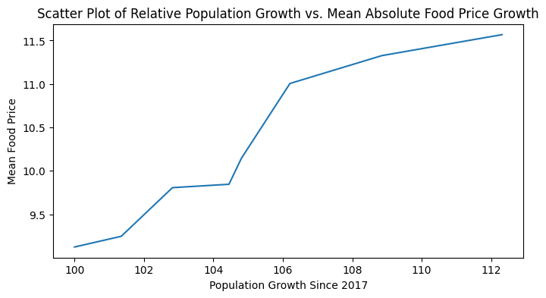

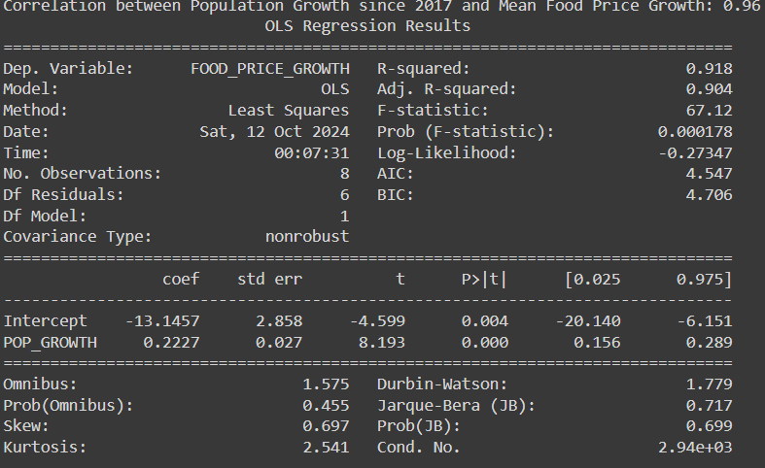

Figure 5: Linear regression modelling procedure taken to create an accurate model of how population growth can affect food prices: µfoodprice = -13.15 + (0.22) µpopulation

An R2 of 0.918 indicates that approximately 92% of the variance in food prices growth can be explained by the relative population growth in Canada. The model explains how as population grows, the food prices will grow alongside, following the basic rule of supply and demand, where more people means more demand for food.

**Key Findings:**

* The linear regression model verifies the dependence of food prices on population growth.
* Food price average per year provides a very broad estimate that allows us to perform a statistical analysis, but it might not be representative of real life, especially for households in the lowest income brackets.
* The only two provinces that show a decrease in food prices are Ontario on Quebec, and only in the last year from 2023 to 2024. It will be interesting to see if the downwards trend continues in the future.

**3. Income Ranges**

**Objective:** To comparehousehold incomes after-tax across Canada.

**Guiding questions:** How many households fit into income categories defined by Canada’s 2021 income tax brackets? Are there specific provinces that have higher/lower household income after tax in Canada?

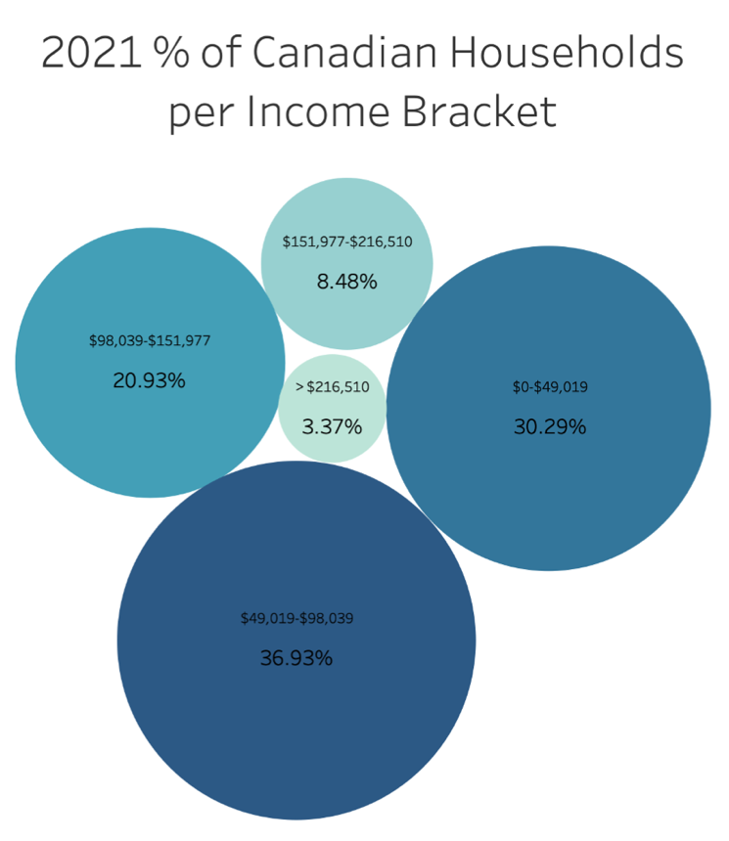**Insights:**

Figure 6: Bubble chart that shows the statistical percentage of Canadian Households that fit into different income after-tax levels.

When it comes to talking about income, it can often be a touchy subject. It's not often you see people jumping to talk about the new raise they just got in their job, and the same goes for that friend who just recently became fun-employed. It can feel like you are getting asked to define your worth based on a number, and people aren’t often quick to disclose their earnings. Luckily for us, the CIS provides data collected from the Canada Revenue Agency on specific incomes of households, so we didn’t need to go ask Canadians to find this information out.

On our first graphic, we looked at the percent of people that fit into specific household income categories based on Canada income tax brackets (figure 6). We chose to divide our population income brackets based off Canada’s 2021 income tax brackets, as this felt like a reasonable way to group income levels for households. We can see from data from the 2021 CIS that over 67% percent of households in Canada make under $98,038 after tax. This makes up 2/3 households and ~26 million Canadians! That’s a lot of households that are under the 6-figure threshold.

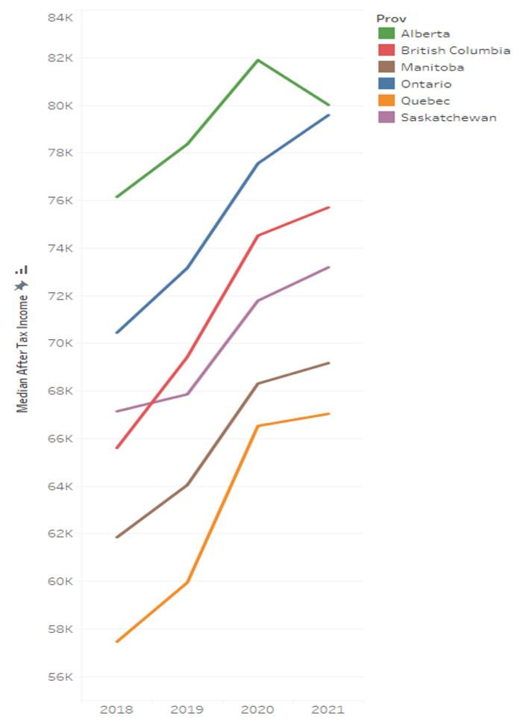Looking further explore income, we completed an analysis on province-to-province income after-tax, excluding the Atlantic provinces and territories:

Figure 7: Line chart of median after tax income in 6 Canadian provinces (excluding Atlantic provinces and territories) from 2018 to 2021.

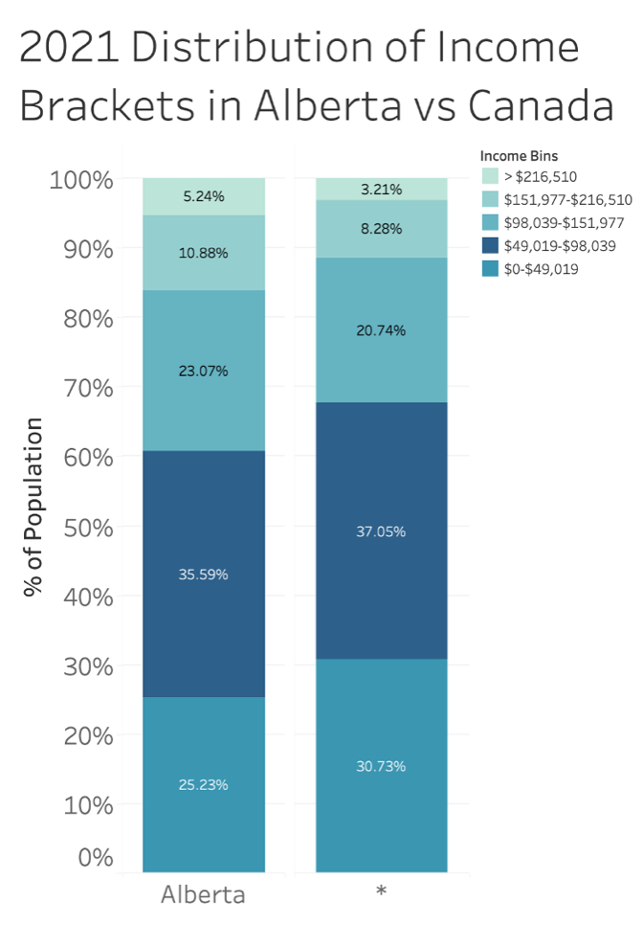

Figure 8: Stacked box plot of the distribution of Albertans in each income bracket compared to the distribution of the rest of Canadians (\*) in each income bracket.

There are some interesting points to take from the visualizations above. First, we can see that every Canadian province analyzed has increasing median after-tax income between 2018 – 2021 (figure 7). With the inflation rate totaling at 8.34% over the period of 2018 – 2021 in Canada (*Canada Inflation Rate 1960-2024*, n.d.), after-tax incomes follow this trend. Most provinces have household after-tax income that increases ~5-10% from 2018-2021.

There is a standout dip in our line graph, particularly in Alberta, on median after tax income from 2020-2021. This can be explained by stress on the economic environment in Canada caused by the Covid-19 pandemic (Moran et al., 2022). The economic shock caused by the Covid-19 pandemic was felt significantly throughout Canada, as many people were forced to work from home, and many lost their jobs. This impact left many forced to rely on government monetary subsidies to survive, and overall, significantly reduced the GDP per capita across Canada from 2020-2022. Alberta in specific felt the most impact in 2021, as the estimated drop in GDP per capita in Alberta was ~8% while the rest of Canada fell ~4% (Di Matteo, 2022).

It’s worth noting that Alberta has the highest annual incomes relative to other provinces. The stacked bar chart above shows that households in Alberta, compared to the rest of Canada, have relatively higher income levels (figure 8). ~39% of households in Alberta have after-tax incomes of over 98,039$, whereas the rest of Canada only has ~32% of households with an after-tax income of over 98,039$. That’s a lot more families that fit into the upper income brackets, which, in theory, should have less struggles when it comes to food affordability. The disproportion in the distributions can be explained by Alberta’s having more jobs that pay higher wages than the rest of Canada (Roach, 2024).

**Key Findings:**

* 2/3 Canadian Households have an after-tax income of under 100,000$
* The Covid-19 Pandemic may have contributed to less income from 2020-2021
* Albertan households make more money on average than the rest of Canada

**4. Money In, Money Out**

**Objective:** To **compare** food spending in Canadian households to how much Canadian households earn after-tax.

**Guiding questions:** How much money do Canadian households make relative to the amount they spend on food? Are there any specific provinces or income brackets that have to spend disproportionately more on food?

**Insights:**

When considering food affordability, a key variable to consider is food spending. We’ve all been to the grocery store before and got caught staring at the register screen as we watch our bill grow and grow and grow. We may be able to tell definitively if food prices are increasing or decreasing by looking at statistics, but does this translate to people spending more money on food? To get a better picture of what food spending looks like, we analyzed data from the Canada Food Spending Survey in comparison to income data collected by the Canada Income Survey.

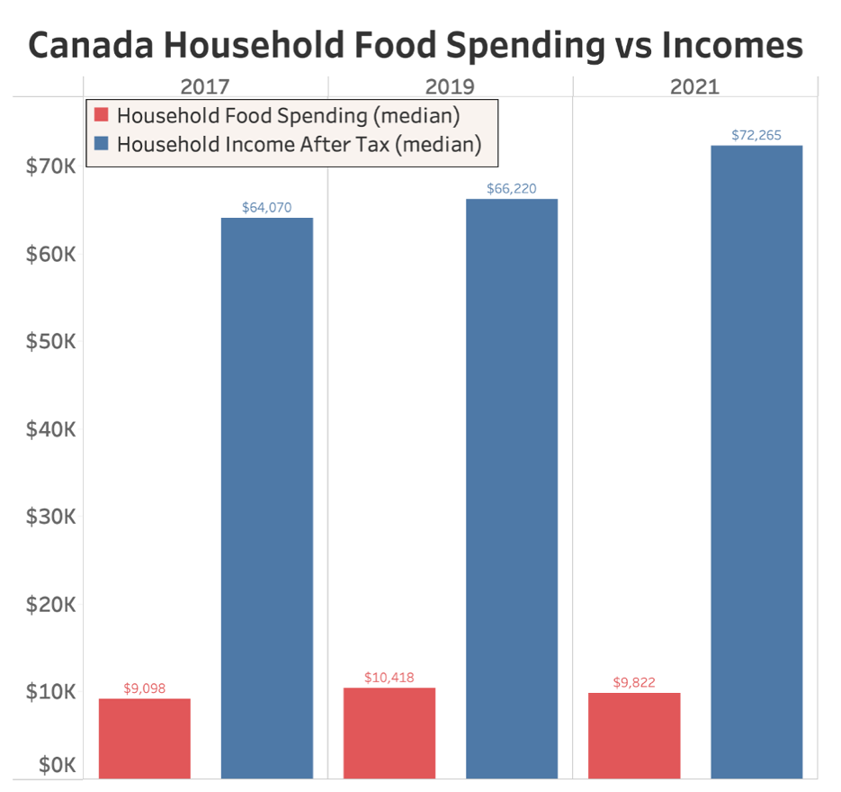When we look at our first graph on spending vs income year to year, we looked into median food spending in Canadian households over time (figure 9). We chose to look at median spending rather than the mean because the distribution of incomes is skewed towards higher incomes. Using the average gave us a less representative evaluation of a normal income. Canadians spending habits haven’t changed drastically from 2017-2021.

Figure 9: Side by side bar chart comparing the median household income after-tax vs median household food spending.

In 2021, median households spent around 14 cents for every dollar made of their earnings on food. When considering this amount on the surface, it doesn’t seem excessive. If we dig deeper, as we have seen from our previous data, we must consider that not all Canadian households earn the same amount of money. To paint a clearer picture, we analyzed food spending in different provinces in Canada and how differing income brackets effects food spending across Canada:

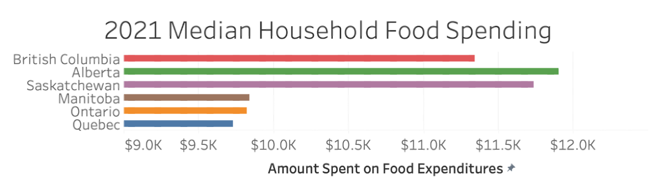

Figure 10: Horizontal Bar Chart on median household food spending for each province in Canada excluding the Atlantic provinces and territories in 2021.

When we consider the median amount spent on food province to province (figure 10), we see that the western provinces in Canada spend significantly more on food than our more eastern counterparts. It's hard to pinpoint a clear reason why this spending trend is the case, as a variety of factors go into food spending. When we look at our previous data on earnings and food prices, there isn’t a clear indication of overly inflated food prices or incomes in the western provinces. Other possible reasons for this increased food spending could be related to spending habits, such as eating out or ordering from food delivery services that tend to be more expensive than buying groceries.

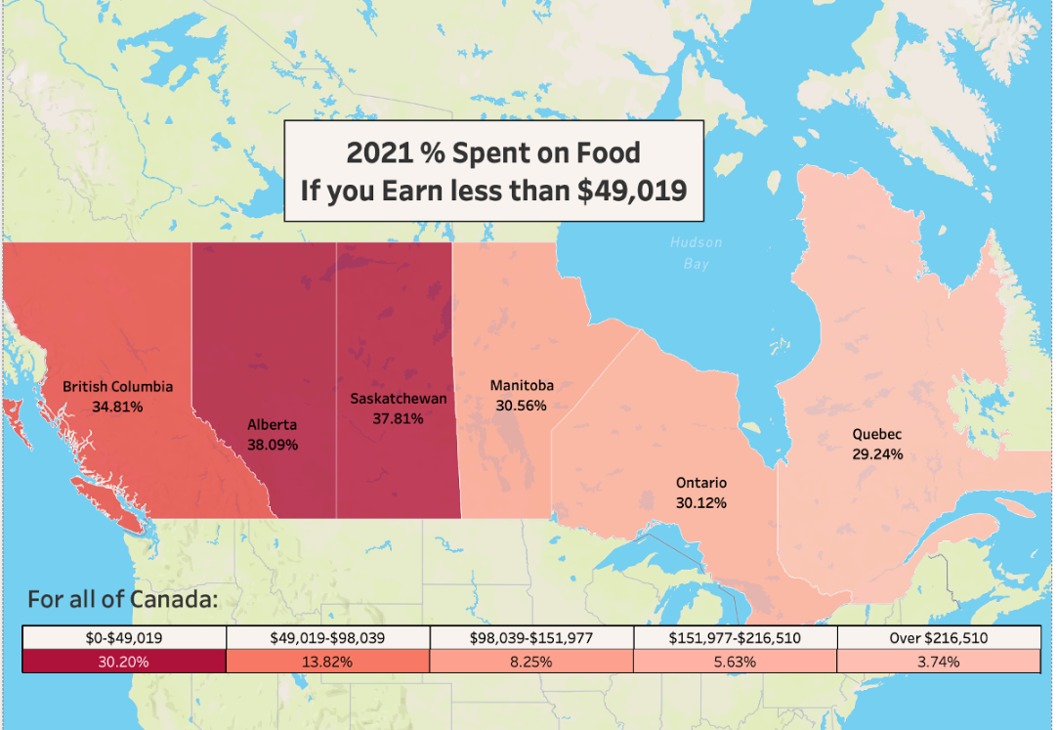

Figure 11: Map of food spending percentage for low-income bracket ($0-$49,019) in the Canadian provinces excluding the Atlantic provinces and Territories in 2021.

Breaking down food spending and comparing it to the lowest household income bracket in Canada in 2021, we see that lower earning Canadians spend are forced to spend relatively more than other Canadians (figure 11). Approximately 30% of all Canadian households fit into the low-income bracket, which is almost 12 million Canadians. Across Canada, we see from the table on the map above that people in this bracket are expected to spend 30% of their after-tax income on food to meet median food spending demands for a household! Even if we consider a single male household who follows our nutrition food guide pricing from part 1 of our analysis ($6,547 annual), this still equates to over 20% of low-income individuals money being spent on food.

Another notable finding is that individuals in the Western provinces who fit into the lowest income bracket spend disproportionately more of their earnings on food. Alberta has the worst percentage spent on food for this demographic, coming in at over 38% of after-tax income going to food spending. Quebec has the best percentage, coming in at 29.24%. From our previous analysis on income, we know that in Alberta people make more money on average and there are significantly less people in the low-income bracket. While Albertans may be making more, this makes their lower income population more at risk of feeling the hit of food inflation. One note to back this claim is that Alberta sees the highest percentage of their population access food banks, with Albertan visiting food banks 116,396 times in March 2021 alone (Fbaa, 2022).

While our data only goes until 2021 on food spending, it appears based on results in the media that the problem of food affordability and spending is only getting worse. According to a recent study in Forbes on food inflation (Reilly-Larke, 2024), food inflation rates from 2021-2024 continue to rise faster than base inflation rates in Canada. Issues that lead to discrepancies province to province are not necessarily policy based, but rather include factors such as supply chain issues, extreme weather effecting product yields, and lack of competition in Canadian grocery markets.

**Key Findings:**

* Low-income Canadian households are forced spend 30% of their earnings on food to match normal spending trends
* Albertan households have the highest food spending rates, which disproportionately effects their low-income households
* To afford a healthy diet for an individual who fits into the low-income bracket will cost them ~20% of their after-tax income

**5. The Core Problem: Food Insecurity**

**Objective**: **Explore** the national and provincial trends for food insecurity across the lowest-income population as well as the rest of Canadians.

**Guiding questions:** How has food insecurity changed in Canada from 2018-2021? What are the most and least food insecure provinces in Canada and why? What have been the most significant years for food insecurity between 2018-2021? What levels of food insecurity can we find among the portion of Canadians that fall into the lowest household income bracket?

**Insights:**

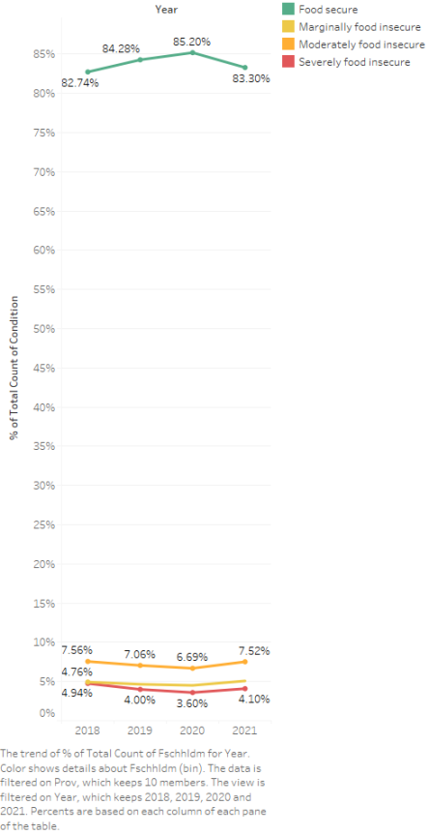 After having discussed issues of food pricing and income, a last and important aspect of food affordability we want to focus on is food insecurity levels. Lacking food security can cause major repercussions for Canadians, including buying less healthy food, buying less food, or buying no food at all. Many of us are well aware that Canada’s quality of life is among the top in the world. You have probably come across those lists on social media that list the best cities in the world to live in, and it may come as a surprise to some (or not) but there’s usually a few Canadian cities in the top ten. Based on the Economist Intelligence Unit report, Forbes magazine reports that Calgary is ranked as the 5th best city (tied with Geneva), while Vancouver shares the 7th spot with Sydney (Bloom, 2024). One might expect that a country with 2 of the top 10 cities in would have very low levels of food insecurity, but the following chart might indicate that food security is still a very prevalent issue in Canada (figure 12).

Figure 12: Canadian food security and insecurity trends from 2019 to 2021.

It’s interesting to note that food security peaked in 2020 at 85.2%, before it declined to 83.3% in 2021. There is a trend in the transition period from 2020 to 2021 evident in several of our previous graphs. For example, different from all the other periods plotted, the population growth flattens from 2020 to 2021, similarly, the median after-tax income still shows an increase (except for Alberta which decreases), but it is much less compared to the increases in other time periods plotted. This time period aligns with a time I’m sure we all remember well as the heart of the pandemic.

When it comes to COVID and food insecurity, the 2023 Hunger Count Report from Food Banks Canada makes a surprising remark. Their reports reads that while the federal government implement a series of temporal social-assistance strategies, the market basket measure (MBM)[[1]](#footnote-1), had shown poverty rates decrease from 2015 until 2020, only to suddenly go back up by 1% from 2020 to 2021. They argue that even this 1% does not accurately capture the reality of millions of Canadians struggling to make ends meet (Food Banks Canada, 2023). Our evidence agrees with these allegations, since we can see a 1.9% decrease in food security throughout the country during the core of the pandemic.

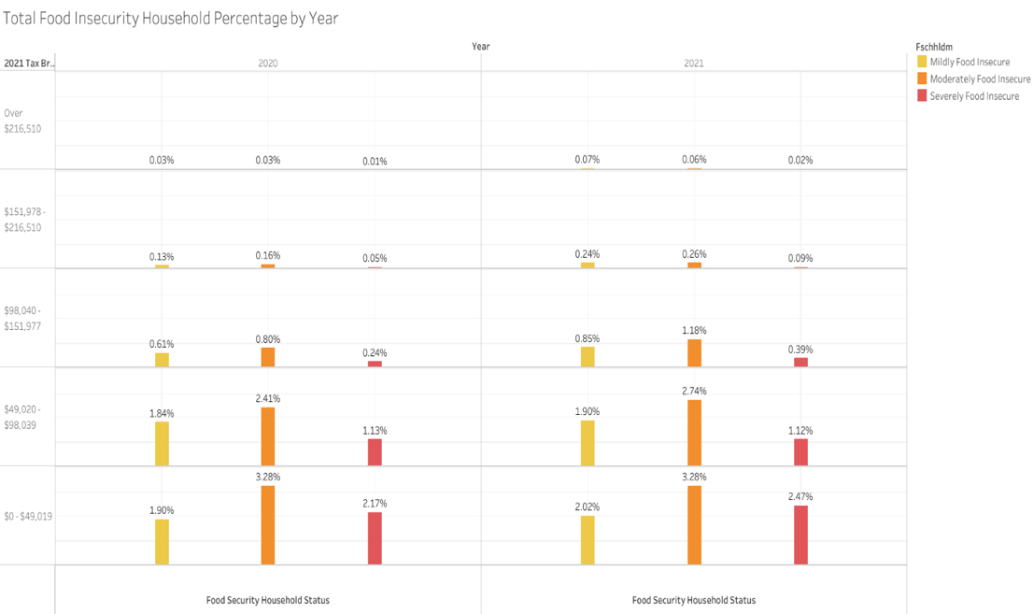

Figure 13: Total food insecurity percentage by year and household income brackets for 2020-2021.

To provide a subset of specific evidence supporting that food security was compromised during covid, we analyzed increases from 2020 to 2021 for the overall Canadian food insecurity rates in low-income households (figure 13). We found that food insecurity rates went from 1.9% in 2020 to 2.2% in 2021 for the mildly food insecure. The moderately food insecure stayed at 3.28% and the severely food insecure grew from 2.17% to 2.47%.

While it's important to consider the entire population when assessing food insecurity, we can gain valuable insights by zooming in on the subset of Canadian households that report experiencing food insecurity.

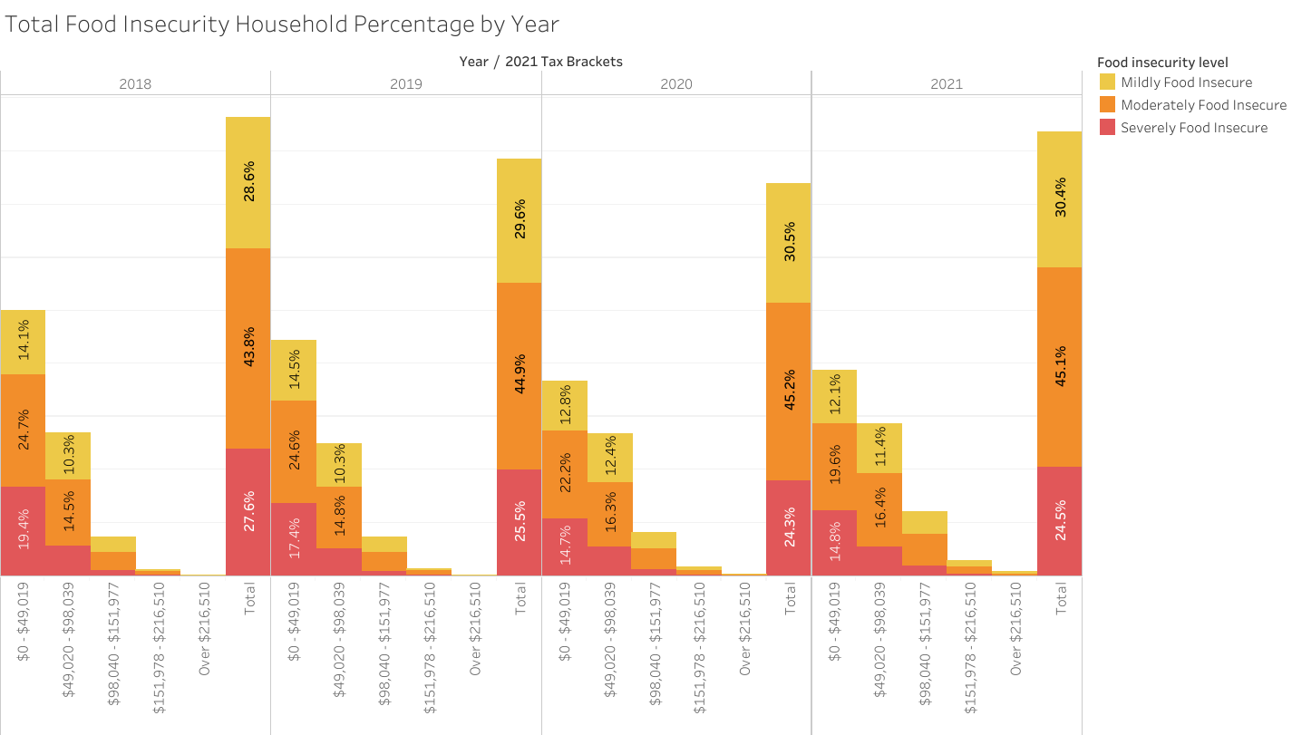

Figure 14: : Stacked bar chart of total percentage of Canada’s food insecure households per year per income bracket.

When we look at food insecurity levels in Canada across income brackets, we can create more insights on the picture of food security as a whole (figure 14). In our graphic, you can extrapolate how much each income bracket was affected compared to the whole population of food insecure Canadians. We can also see specific levels of mild, moderate, or severe food insecurity. When we look at who is affected the most by food insecurity, it is clear that lower income households suffer the most. In 2019 alone, 17.4% of all households who dealt with food insecurity were found to be severely food insecure in the lowest income bracket. Imagine being one of those many households were forced to skip meals and go possibly days on end without food. It’s sad to think how many Canadians this includes, and the pain they must have gone through being unable to feed themselves and their household. It is clear how as we move from lower to higher income brackets, we see a reduced food insecurity rate.

When comparing the total of food insecurity across time, we can see that the severely food insecure proportion has decreased from its highest in 2018 (27.6%) to the lowest in 2020 (24.3%) and rising a bit to 24.5% in 2021. Contrastingly, 2020 had the highest rate of moderately food insecure, and it might be an indication that the smaller percentage of severely food insecure transitioned from severely to moderately food insecure in that year. These overall trends were further analyzed at a provincial level.

Moving from the federal into the provincial scope, we created a map representation of food insecurity levels in the provinces excluding the Atlantic region (figure 15):

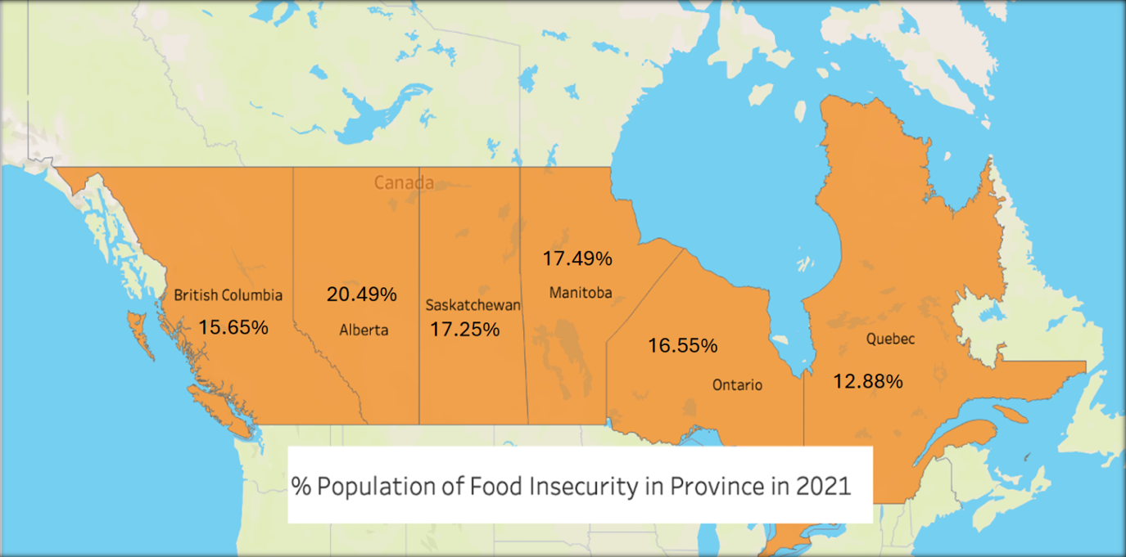

Figure 15: Map of population percentage of food insecure Canadians across 6 provinces in 2021.

At 20.49%, Alberta had the highest food insecurity in Canada in 2021. This means that around 1 in every 5 households in Alberta didn’t meet their basic food requirements at least once throughout the year. On the other side, Quebec had the lowest food insecurity at 12.88%. This poses the question on what is causing this significant 7.61% difference between the two provinces in the same country?

This is no easy task and there is no single report of study online that can give a definitive answer. While there are several factors that impact food insecurity, one major difference between these two provinces is their policy at a provincial level, and it’s well-known that Alberta has traditionally been one of the most conservative provinces in Canada (if not the most) (Penner, 2022). The PROOF household food insecurity 2021 report agrees that provincial government has a major role to play in “protecting their populations from this problem [food insecurity].” (Tarasuk et al., 2021). Unfortunately for the vulnerable population of Albertans, this report suggests that Alberta had a significant drop in caseloads related to social-assistance programs, when altering the eligibility criteria and welfare income.

Similarly, a Global News article provides some more insight (Gibson, 2022). Citing Marjorie Bencz, Edmonton's Food Bank executive director, they mention the struggle in the oil and gas industry in the last few years as a problem affecting a large portion of Albertans. Bencz mentions that the number of people accessing services from Edmonton’s Food banks has doubled from June 2020-2022. Tim Li, a researcher from the PROOF study mentioned earlier, is cited saying that provincial policies, social assistance rates, minimum wage and provincial child benefits have significant impact on household income and consequently food security. Li suggests indexing social assistance benefits to inflation to get a more accurate metric on the problem. Contrastingly, the article cites Alberta’s Social Service Minister Jason Luan stating that “Alberta’s government has committed more than any other province for affordability with more than $2 billion in relief that includes fuel tax relief, electricity rebate, affordable childcare...” (Gibson, 2022).

Based on our literature review findings, we felt it important to look into some other factors that may contribute to food insecurity in Alberta being higher than other provinces. These factors include higher minimum wage and lower unemployment rate, lower income / sales tax, and lower housing price (Men, Urquia, & Tarasuk, 2021). We collected these results and have presented them in the table below (table 1).

|  |  |  |  |  |
| --- | --- | --- | --- | --- |
|  | Ranked | Value | Date | Source (see reference list for full citation) |
| Minimum wage | The lowest in Canada (tied w/ Saskatchewan) | $15 per hour | October 2024 | (Current and forthcoming general minimum wage rates in Canada, n.d.) |
| Unemployment rate | Second highest only after Newfoundland | 7.5% | September 2024 | (Government of Alberta, 2024b) |
| Provincial income tax | Third lowest (after Manitoba / Saskatchewan) | 10% (Manitoba 10.8% and Saks 10.5%) | 2024 | (Canada Revenue Agency, 2024) |
| Sales tax | Best, tied with 7 other provinces and territories | 5% GST | 2023 | (Canada Revenue Agency, 2023) |
| Housing price | 4th highest in Canada, after B.C., Ontario, and Quebec | $486k average | 2024 | (Canadian Real Estate Association, 2022) |

Table 1: Visual representation of some key metrics that may contribute to higher food insecurity levels in Alberta.

We also see it important to look at the flipside of this issue in the most food secure province in Canada. Quebec has put into action much more socially progressive politics than the rest of the country, which may be contributing to this fact. In 2004, Quebec implemented the Government Action Plan to Combat Poverty and Social Exclusion, which included wage subsidization for low-waged workers that provided a substantial increase in disposable income (McIntyre, Bartoo, & Emery, 2012). More recently in 2020, the provincial government introduced the Sustainable Agricultural Plan, that aims to bring Quebec closer to food independence (McLeod 2021). On top of that, Quebec has consistently been amongst the provinces with the lowest unemployment rates in the last few years. (Government of Alberta, 2024b)

While these stats give us a clear picture of the state of food insecurity in Canada, it is worth looking at the subset of Canadians that are affected the most (figure 16).

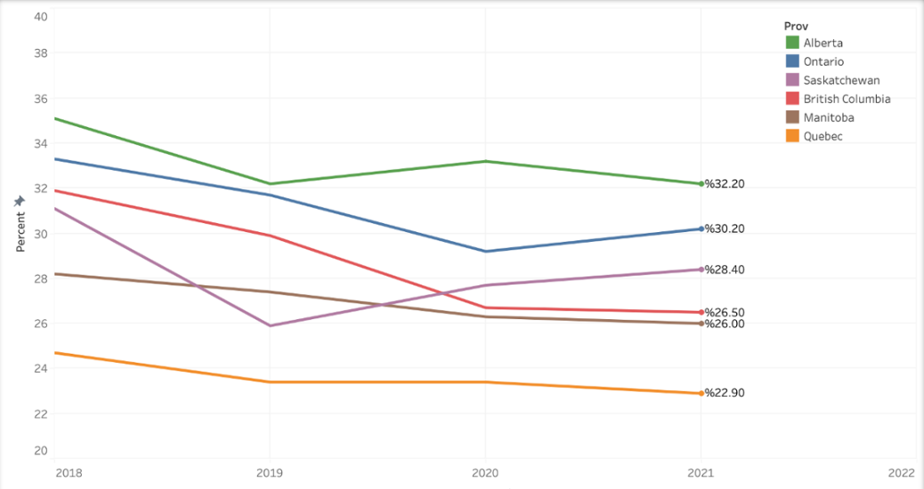 The downward trend in the lowest income households indicates improvements in addressing food insecurity in this demographic, though it is unclear on what measures may be addressing this (figure 16). In agreement with our previous findings, Alberta has the highest rate of food insecurity in lowest income households. While we do see an overall decrease in food insecurity in each province, the high percent of food insecure households in 2021 still posits that there is a critical and ongoing problem of food insecurity for low-income households across Canada. One thing to note is that from 2020 – 2021, statistics show some provinces decreasing their food insecurity rates for the lowest-income tax household and while other provinces have increasing rates of food insecurity. Interestingly, this finding does not align with our previous insight over the whole population food insecurity increase from 2020 - 2021. This means that many lower income Canadians may have been less affected relatively in their food security from the pandemic when compared to Canadians as a whole.

Figure 16: Trend in food insecurity for the lowest household income tax bracket for 2021 ($0-$49,019) across the Canadian provinces excluding the Atlantic region.

One reason we could be seeing a slight detachment from income and food security could come from the great work different organizations are doing in this sector. Going back to 2023 Hunger Count report, “This year’s [2023] food bank usage represents a 32 per cent increase compared to March 2022, and a 78.5 per cent increase compared to March 2019.” (Food Banks Canada, 2023). While food banks are not the solution for such a broad societal and economic issue, they are supporting the most vulnerable population, and while these person’s income isn’t increasing, more Canadians are able to access food through these services.

**KEY FINDINGS:**

* Coming from a steady increasing trend in food security from 2018 –2020, Canada suffered a fall in 2021, likely related to COVID and the state of the world during that year.
* 17.4% of all households in Canada who dealt with food insecurity in 2019 were severely food insecure and in the lowest income bracket
* Alberta has the highest food insecurity in Canada, while Quebec has the lowest.
* Within the lowest income households, food insecurity has decreased overall since 2018 in and across Canada

**Discussion**

Overall, our holistic approach to analyzing food affordability in terms of food pricing, household incomes, household spending, and food security left us with many questions answered and many questions gained. This project was a learning experience for our team. A big challenge we faced as a team and did our best to address in feedback is that the scope of food affordability is huge. Lots of people gave us ideas on other factors that may affect food affordability. We wanted to investigate all these ideas but had to refrain due to the time constraints of our project. We addressed the scope of food affordability to the best of our ability, and there are still many more factors we could consider in future analysis. Through this analysis, we did our best to paint a clear picture on food affordability in Canada.

In terms of food pricing and what a healthy diet is, we saw that it's not cheap to eat healthy in Canada. We found the price to afford the base necessities from the grocery store in healthy diet to be $18.60 a day for meat-eaters and $13.70 a day for a plant-based diet. This doesn’t even include the cost of other necessities, such as toiletries, cleaning supplies, and other common household consumable items. On top of this, not many people have the time to eat only homemade meals. When you’re out and on the run, sometimes it’s more convenient to buy takeout or fast food. We’ve all had a hankering for a snack before and stopped at a local ice cream shop to buy a scoop. Restaurants are often a staple in people's routines, and eating out is a mainstay in our society. In the future, looking into these other factors in conjunction with average food pricing could help paint a clearer picture on food pricing and food affordability.

When looking into population growth and its relationship to food pricing, we found that the two variables are closely related. We observed that both population and average food prices are growing at similar rates across Canada, with only Quebec and Ontario showing any signs of reduced food prices. We tested this relationship further through linear regression analysis and were able to create a model that shows a positive relationship between population growth and food prices. Population metrics in Canada is an important variable to monitor as it relates to increasing food prices. Canada continues to grow, and interventions to increase supply of food may be necessary to avoid drastic growth in food prices and food shortages from higher demand.

We demonstrated household income levels across Canada, and how this income ties into food spending. We were able to find population demographics based of our income data to gain insights on how much Canadians are making, seeing that 2/3 households in Canada make less than $100,000. We saw that Albertans make more money and spend more money on food than the other provinces we analyzed. Our analysis on food spending led to questions too regarding how food spending relates to other spending. In future analysis, a better understanding of food spending in its relation to food affordability could be reached through comparing food spending to other spending relatively in daily life.

Through an exploration into food security statistics, we were able to leverage our data to discover many valuable findings. Analysis of food security levels over time in Canada showed us that food insecurity still needs to be properly addressed, as overall rates of food insecurity remain similar across 2018-2021. Rather surprisingly, rates of food insecurity are declining for Canadian households in the lowest income bracket. We analyzed how impactful the Covid pandemic truly was on Canadians ability to afford food, and how it forced more Canadians into the reality of not having enough food to feed their families. We saw that Alberta deals disproportionately with food insecurity compared to the rest of Canada, which could be due to social policies in place in the province. Vice versa, Quebec implementation of more socially progressive policies have led to them having the lowest levels of food insecurity. Food insecurity is a sad reality for many Canadians. It’s a serious issue that must continue to be evaluated and addressed by Canadian government officials.

In the future, all our team members are interested in circling back to this topic again and looking to expand our understanding of food affordability. Food inflation is such a key issue in society today, considering that food is a necessity for all people. In future studies, we’d be interested in diving deeper into provincial and federal policy to see how their actions have helped and/or hindered food security. Plenty of data aspects could be further explored around this, including wage policies, employment rates, food bank access, social support in place, and so much more. More studies in food affordability should continue to help address where the problem stems from, and how we can best ensure that all Canadians can afford food.

**LIMITATIONS**

Every study of this nature has its limitations, and this one is no exception. One of the first obstacles we encountered was the necessity to merge different data sets to address our guiding questions. Most of our data was contained within the Canada Income Survey (CIS) but these are only published every 5 years after the most recent census, consequently, the latest data available is from 2021. Additionally, Stats Canada has data for food prices and population growth up to the current year, but as mentioned on the introduction, food security levels were only introduced to the CIS in 2018. Hence, in order to conduct a proper analysis, we had 2 time periods that were analyzed: 2017-2024 for food price and population growth and 2018 – 2021 for anything food insecurity-related.

Even though Stats Canada is a highly reliable source, when it comes to food prices, it is impossible to capture all varieties and costs across the provinces. Similarly, when we grouped the food products categories, for example, meats, 1 kg of ground beef is less expensive that 1kg of beef rib cuts (which are both included in the data set), hence, we ran into the necessity of standardizing and averaging all the food prices per category. While our food price index is an estimate, a more thorough categorization process that includes food products from the same price range would be more appropriate to conduct a more accurate analysis that disregards food products that fall into the higher price ranges that Canadians with lower income would possibly avoid.

When analyzing the after-tax income variable in our data set, we noticed that there was a small number of entries that showed negative after-tax income. After doing some research we realized that these outliers accounted for households that have capital losses for any given year. For example, maybe a high-income family that holds a significant amount of wealth in a non-registered account suffers from a loss on any given year (which was very common during the COVID economic downturn) and as a result, has a negative income household for that year. Similarly, another high-income household makes $250k in 2019 but due to a bad economic decision they lose $230k in that same year. In both cases, they would be categorized as low-income (in the lowest tax bracket) for that year without necessarily meaning that they usually fall into this socio-economic level. For that reason, these factors make our analysis harder, and even though we believe those to be a very small subset of the population, it interferes with our analysis.

While the after-tax income variable in the CIS comes directly from the CRA, most of the survey is self-reported. This was apparent when looking at food insecurity levels and people who fall in the highest tax brackets. From our perspective, any household making over $100k after-tax is highly unlikely to be food insecure. Nevertheless, we found 116 families from 2018 to 2021 in the highest-tax bracket (> $216,510 after-tax income) that report to have suffered some kind of food insecurity at least once in that time period. Similarly, in the next tax bracket of $151,978 to $216,510, we see 0.25% of the survey participants for 2018 claim to have some kind of food insecurity, 0.31% for 2019, 0.34% for 2020 and 0.59% for 2021. While there is no way for us to verify these claims, and in certain ways with very specific scenarios we could see this happening, we believe most of these claims are probably false or user errors. We must emphasize again that this is after-tax income, which makes it even harder to believe.

**Conclusion**

Our report looked at food affordability and insecurity from a variety of angles based on public information available on Stats Canada. We focused on household after-tax income, family size, food prices, food spending, and foo insecurity levels, both nationally and provincially. We started providing the cost of a healthy diet as recommended by the Canada food guide and discussed its impact on the most vulnerable. We researched population growth and its effect on food prices. After-tax household income and food spending provided a clear picture of the amounts Canadians are spending on food relative to their earnings. Lastly, and probably most importantly, we analyzed food insecurity levels and trends across Canada.

There are a number of improvements that can be implemented for the betterment of this report. For starters, we could include a variety of other factors that might play a significant role in food insecurity levels such as disability status, health conditions, or number of persons per household. Including demographics can also reveal eye-opening information about those who are most affected. Allowing for the CIS together more data in the coming years would also avoid the necessity to incorporate different data sets that don’t reference the same cross-sectional sample, and thus, have a more comprehensive focus on the topic at hand.

To conclude, we have to demand provincial government to focus on implementing stronger social programs that target those most in need. Programs like those run during COVID could be revisited and re-implemented. While non-for profits and foodbanks provide a strong support, they will not fix the problem. It is on our governments to take the lead and propose policies that have a strong impact on income and food affordability. In the end, only with higher income and government support will we be able to lift Canada from hunger.

**References**

Bloom, L. B. (2024, June 26). *The 20 best cities to live in the world, ranked in a 2024 report*. *Forbes*. <https://www.forbes.com/sites/laurabegleybloom/2024/06/26/the-20-best-cities-to-live-in-the-world-ranked-in-a-2024-report/>

Canada Revenue Agency. (2023, November 30). *Charge and collect the tax – Which rate to charge*. Canada.ca. [https://www.canada.ca/en/revenue-agency/services/tax/businesses/topics/gst-hst-businesses/charge-collect-which-rate.html](https://www.canada.ca/en/revenue-agency/services/tax/businesses/topics/gst-hst-businesses/charge-collect-which-rate.html" \t "_new)

Canada Revenue Agency. (2024, January 23). *Income tax rates for individuals*. Canada.ca. [https://www.canada.ca/en/revenue-agency/services/tax/individuals/frequently-asked-questions-individuals/canadian-income-tax-rates-individuals-current-previous-years.html#toc1](https://www.canada.ca/en/revenue-agency/services/tax/individuals/frequently-asked-questions-individuals/canadian-income-tax-rates-individuals-current-previous-years.html" \l "toc1" \t "_new)

Canada’s food guide. (n.d.). *Canada’s Food Guide*. <https://www.canada.ca/content/dam/hc-sc/migration/hc-sc/fn-an/alt_formats/pdf/food-guide-aliment/track-suivi/table_male-homme_age19-50-eng.pdf>

Charlebois, S., Ducharme, M., Morrison, M., Vézeau, J., & Taylor, S. (2023). The local food paradox: A second study of local food affordability in Canada. *Sustainability, 15*(6), 5199. <https://doi.org/10.3390/su15065199>

Chase, D. L. (2024, January 20). *The cost of living in BC compared to the rest of Canada*. Chase & Associates Receivership Asset Sale Information. <https://bankruptcytrusteebc.ca/blog/the-cost-of-living-in-bc-compared-to-the-rest-of-canada/>

*Current and forthcoming general minimum wage rates in Canada- Canada.ca.* (n.d.). <https://minwage-salairemin.service.canada.ca/en/general.html>

Daly, A., Pollard, C. M., Kerr, D. A., Binns, C. W., Caraher, M., & Phillips, M. (2018). Using cross-sectional data to identify and quantify the relative importance of factors associated with and leading to food insecurity. *International Journal of Environmental Research and Public Health, 15*(12), 2620. <https://doi.org/10.3390/ijerph15122620>

Di Matteo, L. (2022, September 14). *Storm without end: The economic and fiscal impact of COVID in Canada*. Policy Commons. <https://policycommons.net/artifacts/2674029/storm-without-end/3697098/>

Fbaa. (2022, May 10). HungerCount 2021: Food bank use across Alberta among highest in the country. *Food Banks Alberta*. <https://foodbanksalberta.ca/2021-hungercount-alberta-results/#:~:text=HungerCount%202021%3A%20Food%20Bank%20Use%20Across%20Alberta%20Among%20Highest%20in%20the%20Country,-2021%20HungerCount%20Report&text=According%20to%20the%20latest%20HungerCount,the%20highest%20in%20the%20country>.

Food Banks Alberta. (2022). *Lead.Feed.Share*. <https://foodbanksalberta.ca/wp-content/uploads/2023/06/2022-Food-Banks-Alberta-Annual-Report-Final.pdf>

Food Banks Canada. (2023, November 22). *HungerCount - Food Banks Canada*. <https://foodbankscanada.ca/hungercount/>

Gibson, C. (2022, November 3). Alberta has highest food insecurity rate among Canadian provinces: Report. *Global News*. <https://globalnews.ca/news/9079245/alberta-food-insecurity-highest-canada-report/>

Gorski, M. T., & Roberto, C. A. (2015). Public health policies to encourage healthy eating habits: Recent perspectives. *Journal of Healthcare Leadership, 7*, 81–90. <https://doi.org/10.2147/JHL.S69188>

Government of Canada. (n.d.). *Canada’s food guide*. <https://food-guide.canada.ca/en/>

Government of Canada, Statistics Canada. (2022, February 9). *Dictionary, Census of Population, 2021 – Market Basket Measure (MBM).* <https://www12.statcan.gc.ca/census-recensement/2021/ref/dict/az/definition-eng.cfm?ID=pop165>

Government of Canada, Statistics Canada. (2023, November 14). *Food insecurity among Canadian families.* <https://www150.statcan.gc.ca/n1/pub/75-006-x/2023001/article/00013-eng.htm>

Government of Canada, Statistics Canada. (2024, May 1). *Gross domestic product (GDP) at basic prices, by industry, provinces and territories, growth rates.* <https://www150.statcan.gc.ca/t1/tbl1/en/tv.action?pid=3610040202&pickMembers%5B0%5D=3.1&pickMembers%5B1%5D=2.2&cubeTimeFrame.startYear=2021&referencePeriods=20210101%2C20210101>

Grimmelt, A., Moulton, J., Pandya, C., & Snezhkova, N. (2022, October 5). *Hungry and confused: The winding road to conscious eating.* *McKinsey & Company*. <https://www.mckinsey.com/industries/consumer-packaged-goods/our-insights/hungry-and-confused-the-winding-road-to-conscious-eating>

Kishchuk, O. (2023, August 30). *Gen Z – Top issues facing Canada*. Abacus Data. <https://abacusdata.ca/genz-top-issues-facing-canada/>

Lappalainen, R., Saba, A., Holm, L., Mykkanen, H., Gibney, M. J., & Moles, A. (1997). Difficulties in trying to eat healthier: Descriptive analysis of perceived barriers for healthy eating. *European Journal of Clinical Nutrition, 51*(2), S36.

McIntyre, L., Bartoo, A. C., & Emery, J. C. H. (2012). When working is not enough: Food insecurity in the Canadian labour force. *Public Health Nutrition, 17*(1), 49–57. <https://doi.org/10.1017/s1368980012004053>

McLeod, V. (2021, April 13). *A made-in-Quebec blueprint for food security*. McGill Reporter. <https://reporter.mcgill.ca/a-made-in-quebec-blueprint-for-food-security/>

Men, F., Urquia, M. L., & Tarasuk, V. (2021). The role of provincial social policies and economic environments in shaping food insecurity among Canadian families with children. *Preventive Medicine, 148*, 106558. <https://doi.org/10.1016/j.ypmed.2021.106558>

Moran, K., Stevanovic, D., & Touré, A. K. (2022). Macroeconomic uncertainty and the COVID‐19 pandemic: Measure and impacts on the Canadian economy. *Canadian Journal of Economics/Revue Canadienne D Économique, 55*(S1), 379–405. <https://doi.org/10.1111/caje.12551>

Peng, W., & Berry, E. M. (2019). The concept of food security. In *Elsevier eBooks* (pp. 1–7). <https://doi.org/10.1016/b978-0-08-100596-5.22314-7>

Penner, M. (2022, July 24). Alberta is Canada’s most conservative province — but it doesn’t have to be. <https://jacobin.com/2022/07/alberta-ucp-kenney-leadership-oil-gas-fossil-capitalism>

Reilly-Larke, C. (2024, October 10). Food inflation in Canada: What you need to know. *Forbes Advisor Canada*. <https://www.forbes.com/advisor/ca/personal-finance/food-inflation/>

Roach, R. (2024, January 25). Mind the gap. *ATB Financial*. <https://www.atb.com/company/insights/the-twenty-four/disposable-income-in-alberta-2022/#:~:text=Sure%20enough%20Alberta%20had%20the,province%20was%20B.C.%20at%20%2499%2C474>.

Shahbandeh, M. (2024, March 14). Food price inflation in Canada. *Statista*. <https://www.statista.com/topics/9659/food-price-inflation-in-canada/#topicOverview>

Tarasuk, V., Li, T., & Fafard St-Germain, A. A. (2022). *Household food insecurity in Canada, 2021*. Toronto: Research to Identify Policy Options to Reduce Food Insecurity (PROOF). <https://proof.utoronto.ca>

The Fraser Institute, Whalen, A., & Fuss, J. (2023, March 23). Government policies help push grocery prices higher in Canada. *Fraser Institute*. <https://www.fraserinstitute.org/article/government-policies-help-push-grocery-prices-higher-in-canada>

WBCSD. (n.d.). Food affordability. In *Food Affordability* (pp. 3–28). <https://www.wbcsd.org/wp-content/uploads/2023/10/Food-Affordability.pdf>

**DATA SETS**

Government of Canada, Statistics Canada. (2020, February 24). *The Daily — Canadian Income Survey, 2018*. <https://www150.statcan.gc.ca/n1/daily-quotidien/200224/dq200224a-eng.htm>

Government of Canada, Statistics Canada. (2021, March 23). *The Daily — Canadian Income Survey, 2019*. <https://www150.statcan.gc.ca/n1/daily-quotidien/210323/dq210323a-eng.htm>

Government of Canada, Statistics Canada. (2022, March 23). *The Daily — Canadian Income Survey, 2020*. <https://www150.statcan.gc.ca/n1/daily-quotidien/220323/dq220323a-eng.htm>

Government of Canada, Statistics Canada. (2023a, May 2). *The Daily — Canadian Income Survey, 2021*. <https://www150.statcan.gc.ca/n1/daily-quotidien/230502/dq230502a-eng.htm>

Government of Canada, Statistics Canada. (2023b, October 18). *Detailed food spending, Canada, regions and provinces.* <https://www150.statcan.gc.ca/t1/tbl1/en/tv.action?pid=1110012501>

Government of Canada, Statistics Canada. (2024, September 4). *Monthly average retail prices for selected products: Food.* <https://www150.statcan.gc.ca/t1/tbl1/en/tv.action?pid=1810024502>

Government of Canada, Statistics Canada. (2024, September 25). *Population estimates, quarterly.* <https://www150.statcan.gc.ca/t1/tbl1/en/tv.action?pid=1710000901&cubeTimeFrame.startMonth=07&cubeTimeFrame.startYear=2017&cubeTimeFrame.endMonth=07&cubeTimeFrame.endYear=2024&referencePeriods=20170701%2C20240701>

**Contributions**

**Carlos:** During meetings, I kept track of action items and meeting agendas. We all tried to keep each other accountable and on task to meet deadlines. Like most of the team, I first contributed to the data collection process, and later with several data visualization plots, worked on guiding questions and objectives with the group, and editing presentations and early submissions. For the final report, I oversaw our analysis on food pricing, population, food security, limitations, introduction, conclusion and references, and collaborated with proofreading and editing.

**Michael:**  At the projects inception, I helped with data collection by finding the Canada Income Survey (CIS) and researching our datasets extensively. During data wrangling, I completed the initial data cleaning of the CIS, and helped merge the 2018-2021 CIS. I aided in idea formation for our project, including creation of guiding questions, presentation development, and formatting/editing reports. In the final report, I contributed through providing background information on our datasets, creating visualizations and analysis on income and food spending, leading the discussion portion of the report, and led on formatting and editing the final report.

**Yifeng:** In the early stages of the project, I was in charge of collecting our datasets. I found the specific datasets on food pricing data and food spending data. In our data wrangling, I helped by cleaning our food price data sets so that it was ready for price standardization procedures. I assisted in brainstorming of the projects guiding questions, and was a leader in analysis by contributing most visualizations and insights on food insecurity.

**Gagandeep:** For this project I managed the loading and merging of multiple datasets from the Canadian Income Survey from 2017 to 2021 using Python libraries like Pandas and NumPy. I aligned column formats and cleaned data by replacing province codes with meaningful province names, dropping irrelevant columns, handling missing data, and removing duplicates. I developed functions to categorize food products into groups (e.g., Meat, Vegetables) based on their names and converted quantities to standard units for cost calculations. I analyzed health-related food product prices and consumption patterns, breaking them down into daily consumption costs per category. I suggested and implemented the use of tools like GitHub for version control, MS Teams for team collaboration, and Tableau for data visualization, ensuring smooth project completion. I handled various technical issues, such as missing data and inconsistencies in formatting, ensuring the datasets were reliable for analysis.

**Warren:** I came up with a few guiding questions and I made the plot of average/median income trend across all provinces over the years; I also made another graph which is the correlation heatmap graph to show which variables is the most relevant to food spending, However, none of the correlations seemed significant so we decided to not include it. I also assisted in writing the discussion part of the report.

**APPENDICES**

**APPENDIX 1: Data wrangling code**

For our project, we used python for all of our data cleaning and wrangling. All .csv files that were explored and or used, as well as all data wrangling coding files can be found in our [repository](https://github.com/Snacktistics/the_food_analysis.git) on GitHub (<https://github.com/Snacktistics/the_food_analysis.git>). The recommended Jupyter notebook formatting was only done as a last resource to meet the requirements but we strongly suggest to evaluate this pdf instead. We had already complete most of the report when information was released that Jupyter notebook was the preferred method of uploading. This time constraint made it impossible to compile a report to a .ipynb file in a meaningful and well formatted way before our deadline.

**APPENDIX 2: Canada Income Survey Questions on Food Insecurity:**

In the CIS, respondents were asked to answer these specific questions verbatim:

“The following statements may describe the food situation for your household in the past 12 months. Please indicate if the statement was often true, sometimes true or never true for you and other household members in the past 12 months.

You and other household members worried that food would run out before you got money to buy more

* Often true
* Sometimes true
* Never true

The food that you and other household members bought just didn't last and there wasn't any money to get more

* Often true
* Sometimes true
* Never true

You and other household members couldn't afford to eat balanced meals

* Often true
* Sometimes true
* Never true

You or other adults in your household relied on only a few kinds of low-cost food to feed the children because you were running out of money to buy food

* Often true
* Sometimes true
* Never true

You or other adults in your household couldn't feed the children a balanced meal because you couldn't afford it

* Often true
* Sometimes true
* Never true

The children were not eating enough because you or other adults in your household just couldn't afford enough food. Would you say:

* Often true
* Sometimes true
* Never true

The following few questions are about the food situation in the past 12 months for you or any other adults in your household.  
  
In the past 12 months, since last [current month], did you or other adults in your household ever cut the size of your meals or skip meals because there wasn't enough money for food?

* Yes
* No

How often did this happen? Was it:

* Almost every month
* Some months but not every month
* Only 1 or 2 months

In the past 12 months, did you (personally) ever eat less than you felt you should because there wasn't enough money to buy food?

* Yes
* No

In the past 12 months, were you (personally) ever hungry but didn't eat because you couldn't afford enough food?

* Yes
* No

In the past 12 months, did you (personally) lose weight because you didn't have enough money for food?

* Yes
* No

In the past 12 months, did you or other adults in your household ever not eat for a whole day because there wasn't enough money for food?

* Yes
* No

How often did this happen? Was it:

* Almost every month
* Some months but not every month

Only 1 or 2 months

Now, a few questions on the food experiences for children in your household.

In the past 12 months, did you or other adults in your household ever cut the size of any of the children's meals because there wasn't enough money for food?

* Yes
* No

In the past 12 months, did any of the children ever skip meals because there wasn't enough money for food?

* Yes
* No

How often did this happen? Was it:

* Almost every month
* Some months but not every month
* Only 1 or 2 months

In the past 12 months, were any of the children ever hungry but you just couldn't afford more food?

* Yes
* No

In the past 12 months, did any of the children ever not eat for a whole day because there wasn't enough money for food?

* Yes
* No

1. The “official measure of poverty based on the cost of a specific basket of goods and services representing a modest, basic standard of living” (Government of Canada, Statistics Canada, 2022). [↑](#footnote-ref-1)